Executive Summary
July 1, 1998

Goals and Objectives
Massachusetts General Laws, Chapter 87, Acts of 1996, and MassHighway Engineering Directive #E-98-003, prepared in response to the foregoing MGL, both mandate that reasonable bicycle accommodation be provided in project designs. This would logically include bicycle detection at traffic actuated signals. The detection selected must be sensitive enough to detect a bicycle while avoiding false calls from the adjacent lane (splashover). Appropriate detection must also be provided for dedicated bike paths that are not a contiguous element of the paved vehicular roadway and are subject to mixed recreational use (pedestrian, roller blading, etc.).
- Select bicycle detection for general traffic lanes.
- Select bicycle detection for exclusive bike lanes within the paved roadway.
- Select appropriate detection for mixed-use (non-vehicular) recreational bike paths.
- Provide special bicycle pavement markings.
- Provide bicycle informational signs, as necessary.

Decision Recommendation
We recommend several variations of the “quadrupole” loop for bicycle detection to allow for various applications and lane configurations. We recommend push-button actuation for mixed-use (non-vehicular) recreational bike paths. The quadrupole loop provides maximum sensitivity with complete adjacent lane rejection. The push-button application on the recreational bike paths will accommodate pedestrians and rollerbladers as well as bicyclists.

Justification
Staff members reviewed the available literature on bicycle detection. There is a clear consensus in the literature, which, combined with our professional experience, leads us to conclude that one or more variations of the quadrupole meet the criteria established above for roadway use. Push buttons are clearly superior for off-road applications. Placement of bicycle pavement markings must take into account the riding patterns of the bicyclists. Center of the lane application is appropriate only for exclusive bike lanes and general purpose turn lanes. Bicycle markings should be placed to the right side of general purpose through lanes to conform to recommended bike-riding practice (allowing the faster accelerating cars to pass within the lane). Where more than one through lane exists, bike markings should be placed in the right most lane only. Minimum green times should be adjusted to allow for the slower bike acceleration.

Next Steps
The following actions should be taken to fully implement these recommendations:
- Department approval.
- Development of standard details.

Analysis
Bicycle Detection
At
Signalized Intersections

MassHighway
Traffic Engineering and Operations
Electrical Systems Unit

BACKGROUND

Massachusetts General Laws, Chapter 87, Acts of 1996, and MassHighway Engineering Directive #E-98-003, both mandate that accommodations for bicycles be made in project designs.

SPECIFIC SITUATION

The intent is to develop policy for bicycle detection, which will allow bicycles and motor vehicles to safely traverse the roads together.

In Massachusetts, operators of bicycles must follow the same rules of the road as motorists. These rules dictate that slower vehicles should stay to the right and faster vehicles stay to the left.
Bicyclists’ riding patterns should be determined in order to provide effective loop detector placement. Cyclists are most likely to be riding in the following locations
- In a dedicated bicycle lane.
- On the right side of the right travel lane.
- On the left side of a left turn lane (if the lane is a shared use lane for left and through movements).
- On the right side of a left turn lane (if lane is an exclusive left turn lane).
- Just to the right of the centerline when turning left on an ordinary, two-lane street.

Therefore, bicycle detection should be placed at locations described above. It is not practical to force bicyclists to ride in traffic situations where they are not comfortable or are in conflict with recommended bicycle safety practices. We suggest that each intersection be evaluated individually for bicycle detection.

DETECTION

Loop detection for bicycles should be sensitive enough to detect bicycles but should be designed so that the inductance does not spill over into adjacent lanes. The most common loop detectors for bicycles are the following:
Type D-1 (diagonal quadrupole type-1) <Figure 1>
Type D-2 (diagonal quadrupole type-2) <Figure 2>
Type D-Q (Double Quadrupole) <Figure 3>
Type Q (Standard Quadrupole) <Figure 4>

The most commonly used loop detector types in Massachusetts at the present time are the standard square or rectangular loops. These are not suitable for bicycle detection because detection is not provided across the entire width of the loop. Increasing the sensitivity of the loop detector amplifier will cause detection of vehicles in adjacent lanes (splashover effect).

ALTERNATIVE METHODS OF BICYCLE DETECTION

Other methods of bicycle detection have been evaluated. These other methods include:

Detection  Method | Advantages | Disadvantages
Video | - Does not necessitate closure of travel lanes to install  - Can be used in areas with bad pavement | - Expensive if only bicycles are detected
Microwave/  Radar | - Does not necessitate closure of travel lanes to install  - Can be used in areas with bad pavement | - Complex to maintain  - Cannot be used in a presence mode  - Vulnerable to vandalism
Sonic | - Does not necessitate closure of travel lanes to install  - Can be used in areas with bad pavement  - Circular zone of detection | - Hard to control detection zone  - Salt on road alters beam  - Expensive
Infrared | - Does not necessitate closure of travel lanes to install  - Can be used in areas with bad pavement | - Weather makes detection unreliable
Magnetic |  | - Cannot be used in the presence mode  - Very limited area of detection
Magnetometers | - For special locations, such as on or under bridge structures  - Zone of detection is very small (good for exclusive bicycle lanes)  - Perform as well as inductive loop detectors | - Zone of detection is very small (A large number of probes and amplifiers may be necessary for shared lanes)

SIGNS AND PAVEMENT MARKINGS

Where bicycle detection is provided at an intersection, signs and pavement markings should be provided to identify the area of detection and explain the markings to cyclists. These signs are intended to be instructional or educational. Our recommendation for both is attached to this report (See Figures 5 & 6).

OTHER CONSIDERATIONS

Minimum green intervals should be increased at certain wide intersections where bicycle detection is present. This will result in an overall reduction in efficiency of the traffic signal, but is necessary to accommodate the slow-moving bicycle traffic.

Bicycle loops should be wired to separate amplifiers so they may be tuned separately from vehicles. Newer model amplifiers provide higher levels of sensitivity than some older models. Only amplifiers that measure absolute differences in inductance should be used for bicycle detection. Amplifiers which measure percentage change and which have long lead-in cable may not be sensitive enough to detect bicycles.

Bicycle detection loops should be in the base course of the pavement to prevent damage to the pavement surface by the saw-cuts. Where existing pavement is to remain, the areas where loops are to be installed should be milled or cold-planed and the loops installed in the base before final patching.

SUMMARY

Through our research, we have found the quadrupole loop to be the most preferred type of loop detection for bicycles. It has been used successfully in a number of States that have provided bicycle detection at traffic signals. It is relatively simple to lay out in the field and is capable of detecting any bicycle. The size and shape may be varied to suit most locations. The preferred loop configurations are attached to the end of this report, with our recommendation for sign and pavement marking.

We recommend the use of the double quadrupole in exclusive bicycle lanes because it will detect a bicycle which passes anywhere within the loop.

Types D-1 and D-2 may be used either alone or in conjunction with other conventional loops in shared lanes. These loops, used in conjunction with existing standard 1.8x1.8 meter loops, will provide adequate detection for both motor vehicles and bicycles.

Type Q loops will provide adequate detection for both motor vehicles and bicycles. Dimensions may be varied to suit the particular requirements of the location.

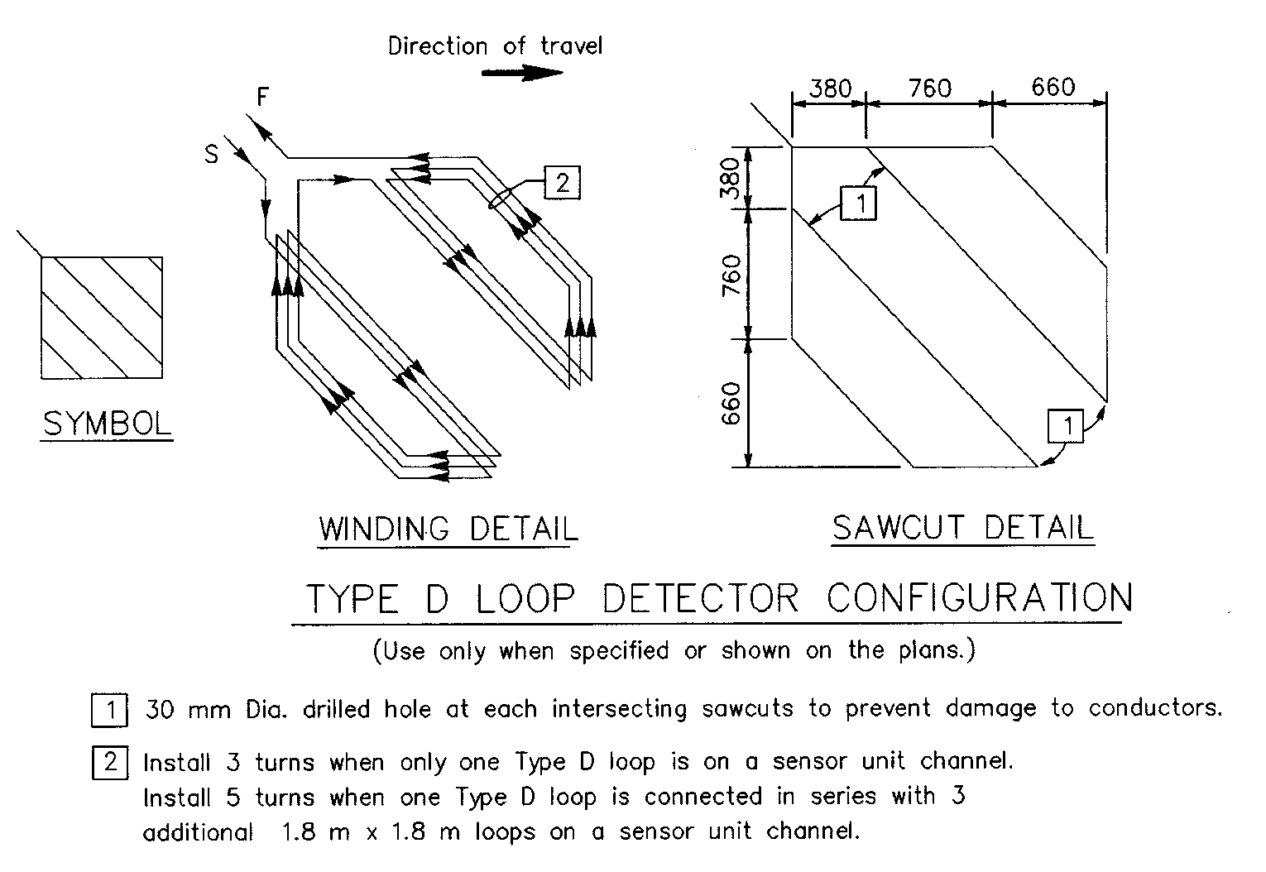

TYPE D-1

Figure 1

1.2 m

1.2 m

1. 2 m 1.2 m

WINDING DETAIL SAWCUT DETAIL

DIRECTION

OF TRAVEL

TYPE D-2

Figure 2

1.4 m

450 mm

450 mm

450 mm

450 mm

TYPE D-Q (Double-quadrupole)

Figure 3

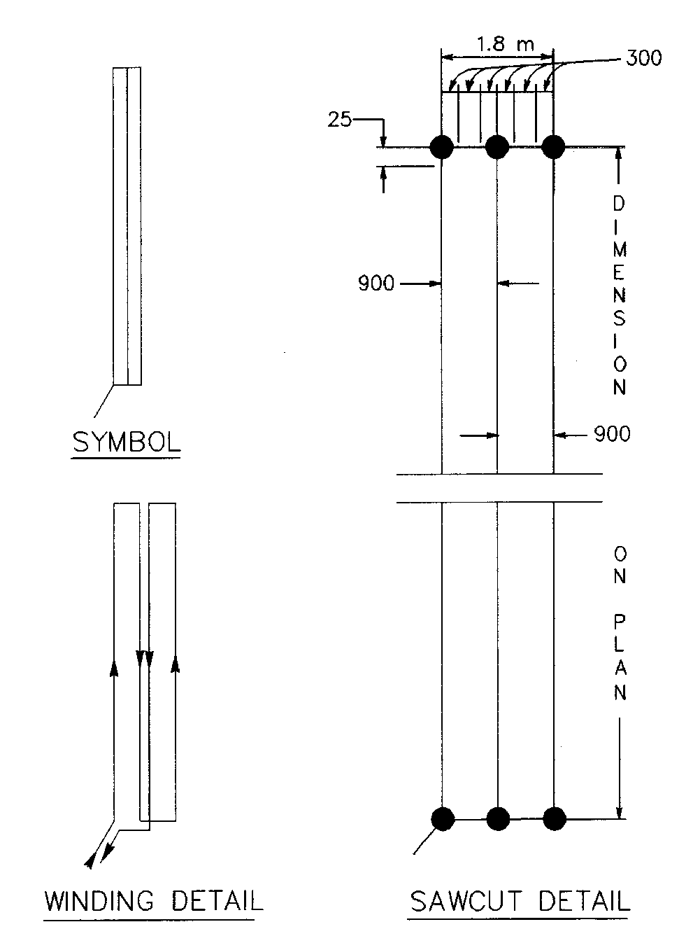

TYPE Q (Standard quadrupole)

Figure 4

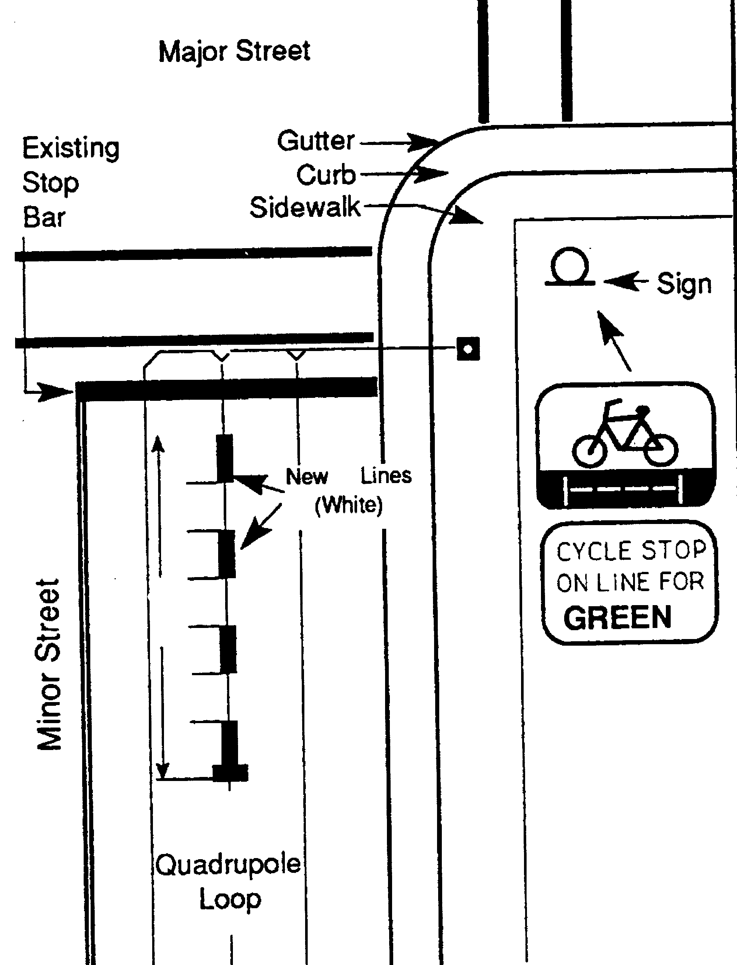

450mm 100 mm

450 mm

450 mm

3.3 m

560 mm

Bicycle detector sign and markings

Figure 5 ⁹

500 mm



400 mm 500 mm 1.5 M

500 mm

Special bicycle pavement marking

Figure 6 ⁹

REFERENCES
1. Allen, John S., (1989), Street Smarts, Emmaus, PA: Rodale Press, Inc.
2. Wood, Don, Evaluating Traffic Signal Detector Loops, Bicycle Forum No. 45, A Quarterly Publication of the Bicycle Federation of America, (June 24, 1997), Missoula, Mt.
, 3. Dodge, Karen-Jayne, and Christopher Skelly, (1994), Building Better Bicycling, Massachusetts Highway Department
4. Guide for Development of Better Bicycle Facilities (Draft), (1997), AASHTO.
5. Inductive Loops, Equipment Development and Test Report No. 7700-9, (Rev. 1983), Missoula, MT: USDA Forest Service.
6. Maki, Pamela, and Peter S. Marshall, (1997), Washington, DC: Institute of Transportation Engineers Compendium of Technical Papers, Accommodating Bicycles at Signalized Intersections with Loop Detectors.
7. Manual on Uniform Traffic Control Devices, (1988),Washington, DC: Federal Highway Administration.
8. Traffic Control Devices Handbook, (1983), Washington, DC: Federal Highway Administration.
9. Traffic Detector Handbook, (1990), Mc Lean, VA: Federal Highway Administration.
10. Traffic Signal Bicycle Detection Study, (1985), La Habra,CA: Mohle, Grover & Associates.

